# FLASH

* Open QMK Toolbox
* Open the location of the new firmware file that you downloaded.
* Unplug the board
* Open up the board and expose the PCB. It’s not necessary to disassemble the entire board, only opening it up
* Locate the 2 pins marked by the BOOT0 silkscreen mark. Pictured below:

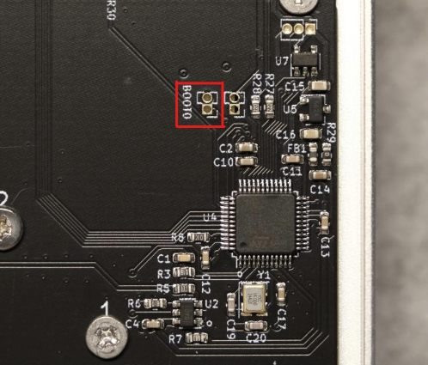

* Short them with tweezers or a piece of wire and keep it shorted
* With the pins still shorted plug the board back in
* The board should be recognized as a DFU device in QMK Toolbox
* Verified that the board was recognized in flash mode, you can now remove the tweezers/wire
* The flash button now should be enabled (if not then the board wasn’t in DFU mode, retry the above steps)
* Hit the flash button
* Once the flashing procedure is completed you can close the QMK Toolbox.

# CALIBRATION (MANDATORY)

Follow the video guide: [EC PCB Calibration Guide](https://youtu.be/Zg9L5gupvk8)